GDP II - Final Report
REDOX – PROTECT THE WORLD
By: (sec - 07) Team 01

CLIENT INFO

Name: Dr. Michael Bellamy (Professor)

Team Members
Pranathi Reddy Jeedipally (Lead)
Sai Ram Reddy Muthyala
Sai Krishna Reddy Seelam
Varun Kumar Reddy Bhavanam
Sumanth Yeruva
Vennela Reddy Baddam
Ram Niteesh Reddy Bandi

Contents
1. Introduction 4
1.1 Purpose and Scope 4
1.2 Overview, Motivations, and Impact on the Organization 4
1.3 Definitions 4
1.4 Future Plans 5
2. Project Management Plan 5
2.1 Team Organization 5
2.2 Risk Analysis 6
2.3 Software and Hardware Requirements 6
3. Requirement Specifications 7
3.1 Stakeholders of the System 7
3.2 Functional Requirements 8
3.3 Non-Functional Requirements 9
4. Architecture 9
4.1 Architecture Model 9
4.2 Components 10
4.3 Interfaces 11
4.3.1 Login Screen for Professor 11
4.3.2 Main Menu 11
4.3.3 Login Screen for player 11
4.3.4 Registration Screen for player 11
4.3.5 Game Screen 11
4.3.6 Level completion Screen 12
5. Technologies Used 12
5.1 Front End 12
5.2 Back End 12
5.3 Database 12
6. Testing 12
6.1 Features to be Tested. 12
6.1.1 User Interface (UI) 12
6.1.2 Gameplay Mechanics 12
6.1.3 Game Logic 12
6.1.4 Level-Specific Features 13
7. Deliverables 13
7.1 How it works. 13
7.2 User Manual 13
7.3 Screenshots with Explanation 17
7.3.1 Login Screen 17
7.3.2 Registration Screen 17
7.3.3 Main Menu Screen (After Login) 18
7.3.4 Level 1 Screen 19
7.3.5 Level 1 Winning Screen 19
7.3.6 Level 1 Losing Screen 20
7.3.7 Level 2 Screen 21
7.3.8 Level 2 Winning Screen 21
7.3.9 Level 2 Losing Screen 22
7.3.10 Level 3 Screen 23
7.3.11 Level 3 Winning Screen 23
7.3.12 Level 3 Losing Screen 24
7.3.13 Level 4 Screen 25
7.3.14 Level 4 Winning Screen 25
7.3.12 Level 4 Losing Screen 25
7.3.13 Professor’s Login 26
7.4 Project Website Links 30
7.5 GitHub Link 30

1. Introduction
The game Redox-Protect the World fits seamlessly within the 2D game framework. By leveraging the simplicity and creativity of 2D game mechanics, it introduces players to engaging gameplay centered around chemistry concepts, particularly redox reactions. The 2D format allows the game to be accessible to a broader audience, making it an ideal educational tool while remaining entertaining and visually appealing.

1.1 Purpose and Scope
"Redox: Protect the World" aims to revolutionize the approach to teaching redox chemistry by transforming it into an engaging and immersive educational game. The project seeks to bridge the gap between traditional classroom learning and modern, interactive methods, providing students with a dynamic platform to explore the intricate world of redox reactions. By gamifying the learning process, the project endeavors to ignite students' curiosity and passion for chemistry, fostering a deeper understanding and appreciation for this fundamental branch of science.

1.2 Overview, Motivations, and Impact on the Organization
The primary target audience for "Redox: Protect the World" is Chemistry 1 classes, comprising students at the introductory level of their chemistry education journey. These students are at a crucial stage where foundational concepts, such as redox reactions, lay the groundwork for more advanced studies in chemistry. The game is tailored to cater to the unique learning needs and preferences of this demographic, offering an interactive and stimulating educational experience that resonates with their interests and motivations.

1.3 Definitions
- 2D Game:
A game designed with two-dimensional graphics, where characters and objects move on a flat plane, emphasizing simplicity and creativity in gameplay mechanics and visual design.
- Redox Reaction:
A fundamental chemical reaction involving the transfer of electrons, comprising oxidation (electron loss) and reduction (electron gain). These reactions are pivotal to energy production and environmental processes.
- Educational Game:
A type of game that combines learning objectives with interactive gameplay to enhance understanding and retention of academic concepts. Redox - Protect the World integrates chemistry learning with entertaining gameplay.
- Game Mechanics:
The rules and systems that govern player interaction within the game. In Redox - Protect the World, mechanics include shooting the reducing and oxidizing components that are falling from top of the screen.
- Sprite:
A two-dimensional graphical element representing characters, objects, or environments in a game. Sprites in this game depict molecules, reactions, and player(in the form of shooter plane).
- Physics terminology:
This Game was developed by using some physics terms called Gravity for falling the options and offset X and offset Y for moving the player plane.
- Game Environment:
Game consists of two major applications called Scenes and Scripts. Each scene is associated to respective script which has game logics in it. Different scenes are implemented by inheriting different backgrounds known as Parallax Background, Node2D and Physics process.
- Gamification:
The application consists of Game elements like scoring the points in the form of progress bar, Loosing the chance in the form of health, Identification of correct and wrong answers in the form of audio.mp3 format.

1.4 Future Plans
- Improve the Graphics and enhance the background if necessary.
- Adding the QUIZ level.
- Connect the better server for easy deployment.

2. Project Management Plan

2.1 Team Organization

Team Member | Responsibilities
Pranathi Reddy Jeedipally | Project management, client communication, overall supervision, Documentation, Godot learning
Sai Ram Reddy Muthyala | Backend development, database management.
Sai Krishna Reddy Seelam | Identifying Bugs, UI/UX design.
Sumanth Yeruva | Godot learnings, Audio and Physics Process.
Vennela Reddy Baddam | Backgrounds and Visual enhancements.
Ram Niteesh Reddy | Godot learnings, Audio, Handling GD Scripts.
Varun Kumar Reddy Bhavanam | Godot learnings, UI/UX design and Animation enhancements

2.2 Risk Analysis
Potential Risks and Mitigation Strategies
Risk Description | Impact Level | Probability | Mitigation Strategy
Technical Challenges | High | Medium | Conduct thorough research, seek online tutorials, allocate extra time for technical problem-solving.
Time Management Issues | Medium | Medium | Develop a detailed project plan, regularly track progress, adjust the schedule as needed.
Integration Challenges | High | Medium | Develop integration plans early, perform frequent integration tests, use compatible technologies.

2.3 Software and Hardware Requirements

Software Requirements
- Game Engine: Godot Engine.
- Scripting Language: GDScript (Godot's scripting language).
- Physics Engine: Integrated within Godot for character movement and bullet physics.
- Database: MySQL Database for structured data storage and potential remote server storage for online features.
- Scene System: Utilized for organizing game elements within Godot.
- Signals and Connections: Used for handling interactions between game objects.
- Custom Game Scenes: Created within Godot for specific game elements and interactions.
Hardware Requirements
- Processor: Intel i5 or higher, AMD Ryzen 5 or higher
- RAM: Minimum 8GB (16GB recommended for smooth operation)
- Storage: Minimum 256GB SSD (512GB recommended)
- Desktop and Laptop Computers: Windows, macOS, Linux environments for cross-platform testing
Additional Development Tools
- Integrated Development Environment (IDE): Visual Studio Code.
- Middleware: NodeJS.
- Version Control: GitHub.
- Project Management: Jira.
- Build Tools: Godot's built-in export and build tools.

3. Requirement Specifications

3.1 Stakeholders of the System
- Dr. Micheal Bellamy
- Dr. Aziz Fellah
- Northwest Missouri State University
Internal stakeholders
- Jeedipally Pranathi Reddy
- Sai Ram Reddy Muthyala
- Sai Krishna Reddy Seelam
- Ram Niteesh Reddy Bandi
- Vennela Reddy Baddam
- Sumanth Yeruva
- Varun Kumar Reddy Bhavanam

ID | Title | Description | Priorities | Dependency
FR01 | Choosing the Level | Players could be able to choose the levels of the game in the dropdown list. | P1 | None
FR02 | Level wise transitions | Players would be able to move successive level if and only if previous level completes. | P1 | FR01
FR03 | Includes Lives | Lives may decrease if the player hits the wrong. | P1 | None
FR04 | Stay Back | If Player fails to clear a level, they should retake it. | P1 | FR03
FR05 | Display the Prompt | The question must be displayed at right corner of the screen. | P2 | None
FR06 | Pass Level | Users must answer 7 out of 10 to pass the level. | P1 | FR03
FR07 | Knowledge Meter | Screen must display the percentage increase after choosing correct answer. | P2 | None
FR08 | Includes Sound | Assign different sounds for correct and wrong answers. | P2 | None
FR09 | Increase Speed | Level speed must be increased compared to previous level . | P1 | FR01
FR10 | Chemical equation in level 3 | Hardest and Lengthy question from level 3 includes chemical equation. | P1 | FR14
FR11 | Pause Button | Include pause button which lasts between 10 to 15 sec from level 3. | P2 | None
FR12 | Oxidation and Reduction | Level 4 must include oxidation and reduction question on the given chemical reaction. | P1 | FR14
FR13 | Floating options for level 4 | Options float for level 4 without falling and failing the player. | P1 | FR01
FR14 | Random Questions | Random questions from set of 50. | P1 | FR15
FR15 | Update to database | Each level score and progress of the player will be uploaded to the Database. | P1 | FR02

3.2 Functional Requirements

3.3 Non-Functional Requirements
ID | Feature | Description | Priorities
01 | Performance | The application should load questions and respond to user actions within 2 seconds | High
02 | Scalability | The system should be able to handle concurrent users without performance degradation. | Medium
03 | Maintainability | The codebase should be modular and well-documented to facilitate easy updates and maintenance. | High
04 | Security | User data should be securely stored and transmitted, complying with relevant data protection regulations (e.g., GDPR). | High
05 | Backup and Recovery | The system should have backup recovery plan daily. | Medium
06 | Logging and Monitoring | Logging and monitoring for tracking the progress. | Medium
07 | Testing | Entire game should undergo a vigorous testing phase to ensure it meets all the requirements. | High
08 | Compatibility | The Game should be supported by all the browsers. | Low

4. Architecture

4.1 Architecture Model
The architecture of the game is based on a client-server model, utilizing a modular design that allows for scalability and maintainability. The game engine, Godot, is used for development, with MySQL as the database management system.
High-Level Architecture
Client-Side:
- Game Engine: Godot Engine
- Scripting Language: GDScript
- User Interface: Godot's built-in UI components
Server-Side:
- Database: MySQL for structured data storage
- Backend Framework: Node.js for handling API requests

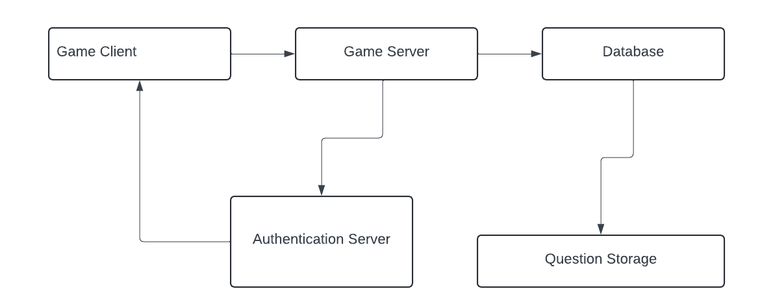

4.2 Components
Game Client:
- Handles game logic, rendering, and user interactions.
- Communicates with the server for data storage and retrieval.

Database:
- Stores user data, game progress, and other persistent information.
- MySQL database deployed on a cloud server for remote access.

Server:
- Manages API requests from the game client.
- Interfaces with the MySQL database to perform CRUD operations.

Communication Layer:
- Uses RESTful APIs for client-server communication.
- Ensures secure and efficient data exchange between the game client and server.

4.3 Interfaces

4.3.1 Login Screen for Professor
Admin: Admin can login and can download excel sheet of the score.
- Professor can perform CRUD operations on each question based on levels.
- They can add questions if needed.

4.3.2 Main Menu
Level Selection: Displays 4 levels.
Instructions Button: Provides instructions for playing the game.
Language Menu: Allows users to select their preferred language.

4.3.3 Login Screen for player
User Email: This will used to input Email for player.
Password: User will enter password in this field.

4.3.4 Registration Screen for player
This screen will consist of text boxes for
- First Name
- Last Name
- E-Mail
- Password
- Confirm Password
- Section selection
- Section Code

4.3.5 Game Screen
Knowledge Meter: Reflects the user's progress as a percentage.
Lives Indicator: Displays the number of lives remaining.
Pause Button: Available in Level 3 and Level 4, pauses the game for a specified time.
Quit Button: Available in Level 3 and Level 4.
Player Plane: Used by the player to shoot the components.
Question Label: Question displays on the top right corner of the screen.
Question Number: Question Number displays below the question text. Ex: Q. No: 2/10

4.3.6 Level completion Screen
Scoreboard: Displays the user's score and progress.
Menu Button: Proceeds to the Main menu screen.

5. Technologies Used

5.1 Front End
- TSCN files for Game Scenes
- JavaScript for professor site
- HTML
- CSS

5.2 Back End
- GD Script
- JavaScript
- HTML
- SQL
- NodeJS as framework

5.3 Database
- MySQL Database for structured data storage and potential remote server storage for online features

6. Testing

6.1 Features to be Tested.

6.1.1 User Interface (UI)
- Menu
- HUD (Heads-Up Display).
- Buttons, sliders, and other interactive UI elements.
- Placing the precise images.

6.1.2 Gameplay Mechanics
- Character Movement.
- Physics and Collision Detection.
- Bullet speed Mechanics.

6.1.3 Game Logic
- Game State Management.
- Score Calculation.
- Event Handling.

6.1.4 Level-Specific Features
- Level 3 Testing: Ensure the speed of the options.
- Level 4 Testing: Basic mechanics for floating options.

7. Deliverables

7.1 How it works.
- Begin by downloading and installing the latest version of the Godot application.
- Next, download the game’s zip file from the provided GitHub repository or use GitHub Desktop for easier tracking of future enhancements and bug fixes.
- Once downloaded, extract the contents of the zip file. Navigate to the root folder, where the main game files are located, and copy the path, which should resemble C:\GDP-1\GDP_REDOX_TEAM1\Godot project\Godot.
- Open Godot Engine, click on "Import," and paste the copied path. Press Enter, select "Current Folder," and when the popup appears, choose "Import & Edit."
- The game’s source code and scenes will now load into their respective areas within Godot.
- To play the game, click the "Play" button in the top-right corner. You can also choose to run specific scenes individually using the available options.

7.2 User Manual
For Students – To Play the Game
Game Link: https://redox-protect-the-world.itch.io/redox
Steps to Play the Game
Step 1: Go to the Register page on the game website.
- Enter the following details:
  - First Name
  - Last Name
  - Email
  - Section
  - Passcode (provided by your professor, specific to your section)
- Click Register to complete your account creation.
Step 2: After registration, log in using your email and the credentials you created.
Step 3: Navigate to the Level Menu Page, where you will see the following levels:
- Level 1: Basic questions on Assigning Oxidation Numbers.
  - Speed: Normal pace.
  - Example: Assign oxidation numbers to the elements.
  - Lives: You have 3 lives. Each wrong answer reduces one life.
  - Quit Button: Quit anytime if you cannot complete the level.
  - Completion Rule: Answer at least 7/10 questions (70%) correctly to move to the next level.
- Level 2: Same type of questions as Level 1 (Assigning Oxidation Numbers), but with increased speed.
  - Speed: Faster pace than Level 1.
  - Example: Assign oxidation numbers in a timed challenge.
  - Lives: 3 lives. Each wrong answer reduces one life.
  - Quit Button: Quit anytime if you cannot complete the level.
  - Completion Rule: Answer at least 7/10 questions (70%) correctly to move to the next level.
- Level 3: Questions involve Chemical Equations where players must identify the oxidized and reduced compounds.
  - Example: In the reaction identify which compound is oxidized and which is reduced.
  - Lives: 3 lives. Each wrong answer reduces one life.
  - Pause Button: A Pause Button is available to temporarily stop gameplay and resume when ready.
  - Quit Button: Quit anytime if you cannot complete the level.
  - Completion Rule: Answer at least 7/10 questions (70%) correctly to move to the next level.
- Level 4: Higher-difficulty questions combining concepts of Oxidation and Reduction in complex scenarios.
  - Example: Analyze the reaction mechanism and identify oxidation/reduction steps in a multi-step process or balance complex redox reactions.
  - Lives: 3 lives. Each wrong answer reduces one life.
  - Quit Button: Quit anytime if you cannot complete the level.
  - Completion Rule: Answer at least 7/10 questions (70%) correctly to complete the game.
Note: Only levels you have unlocked will be clickable.
Step 4: View the game instructions by clicking "Instructions" on the menu or settings page to understand the gameplay, controls, and objectives.
Step 5: Start by playing Level 1. Progress through levels by completing each one successfully. Each level introduces new challenges:
- Levels 1 and 2 test speed and accuracy in assigning oxidation numbers.
- Level 3 focuses on identifying oxidized and reduced compounds in equations.
- Level 4 challenges you with complex oxidation and reduction scenarios.
For Professor – To Manage Questions and Students
This guide provides a clear, step-by-step explanation of how professors and administrators can navigate and use the Redox Chemistry Quiz Web Application. The application consists of three primary pages: Welcome Page, Login Page, and Dashboard Page.
Link to access Professor Application: https://redoxui.onrender.com/
Welcome Page
The welcome page serves as the entry point to the web application. Professors and administrators can perform the following actions:
- Login for Existing Users
  - Click on the Login button to navigate to the login page.
  - This option is for users who already have registered accounts.
- Request Registration for New Users
  - If you are a new user, click on the Contact Admin button.
  - Fill out the registration request form, providing the necessary details such as name, email, and designation.
  - Submit the form, which will be reviewed by an administrator for account creation.
Login Page
Only registered users can log in from this page. Follow these steps:
- Enter Login Credentials
  - Input your username and password in the respective fields.
  - Use the Show Password checkbox to toggle visibility of your password.
- Login
  - Click on the Login button.
  - If the credentials are correct, you will be redirected to the Dashboard Page.
  - If you encounter errors, you’ll see an error message prompting you to try again.
Dashboard Page
The dashboard is the core page of the application where professors can manage and analyze their content. Once logged in, the dashboard offers several options through labeled buttons.

1. Add Questions
- Clicking this button allows you to:
  - Add New Questions: Create quiz questions and categorize them by difficulty level or topic.
  - Save Changes: Ensure all added questions are securely stored in the database.
2. View Questions
- This button provides access to:
  - View All Questions: Browse through all the quiz questions stored in the system.
  - Edit/Delete: Modify or remove existing questions.
  - Search: Find specific questions using filters such as level, topic, or keyword.
  - Download Reports: Export a report of all questions in a downloadable format (e.g., PDF).
3. Student Scores
- This section allows you to:
  - View Scores: Examine the performance of students across different sections.
  - Download Reports: Generate detailed reports of scores by section or individual performance.
  - Mark Sections as Completed: Move students who have completed their sections to a completed status.
4. Manage Section Codes
- Professors can manage section authentication codes:
  - Create New Section Codes: Generate unique section codes for different class sections.
  - Update/Delete Codes: Modify or remove outdated codes as needed.
  - Distribute Codes: Share these codes with students for registration.
5. Logout
- To exit the application securely, click on the Logout button.

7.3 Screenshots with Explanation

7.3.1 Login Screen
Login is the initial screen for the players to login into their accounts by using Mail and Password. It also contains the Registration link which helps for the player if not registered. In addition, it contains the forgot password link used to retrieve the password.
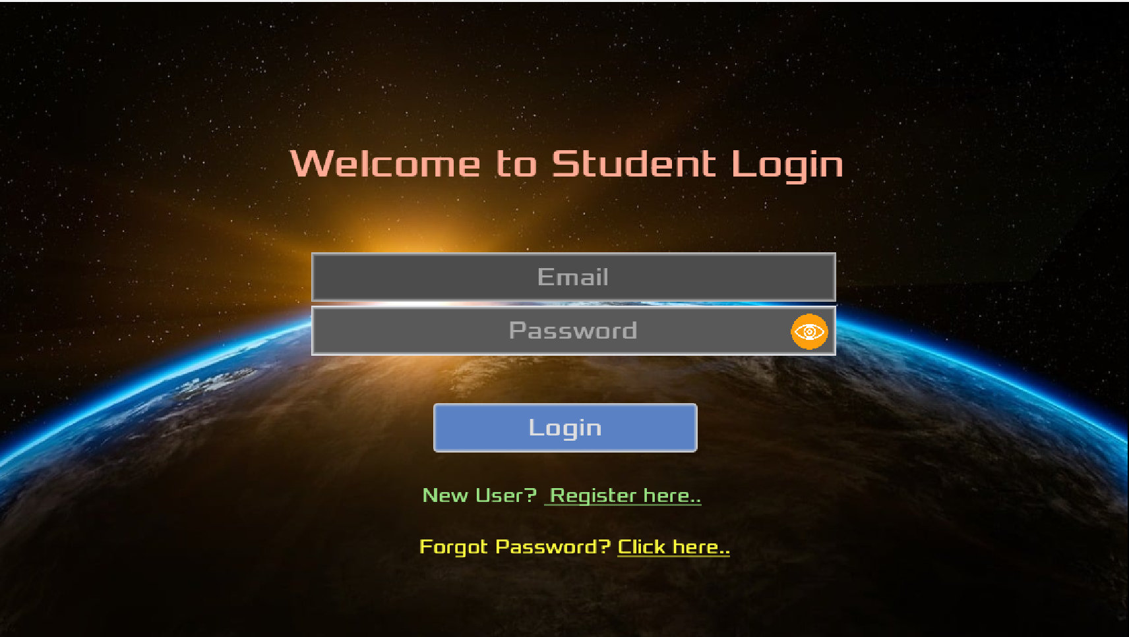

7.3.2 Registration Screen
Registration page helps the players to register themselves by using their
- First Name
- Last Name
- E-Mail
- Password (Minimum length of 8)
- Confirm Password (Should be same as password)
- Section selection
- Section Code (will be set by the professor that prevent others to register)
It also contains back button on top left corner to go back to login screen after registering.
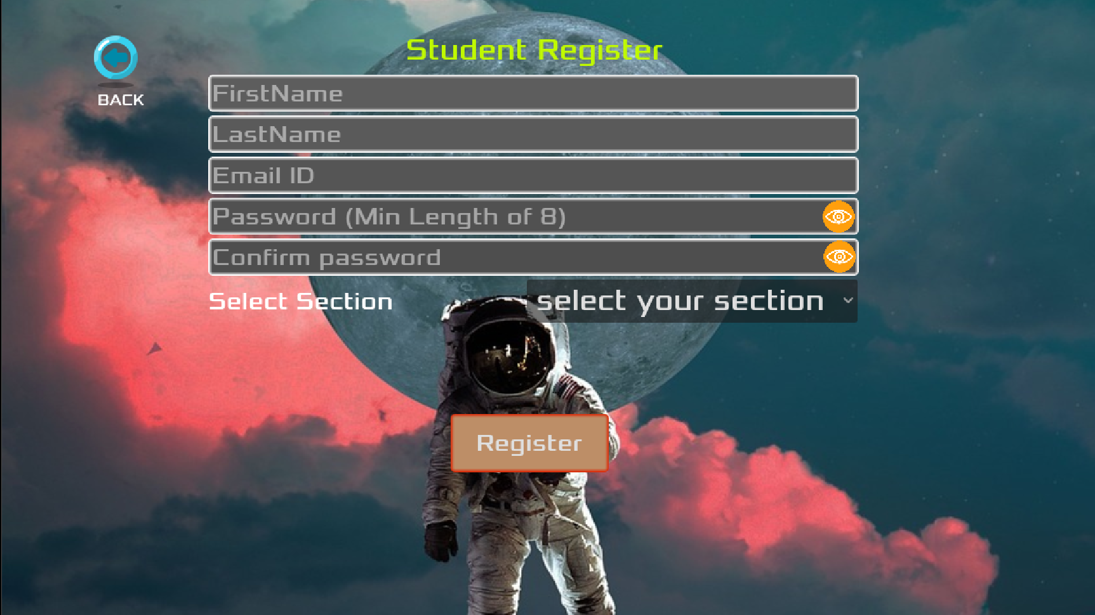

7.3.3 Main Menu Screen (After Login)
After successful login, the main menu consists of level selection along with locks and unlocked symbols based on player’s progress. There is an instructions button on bottom right corner which has all the instructions and guide for the players. A back button beside the instructions button navigates player back to login screen upon clicking it.
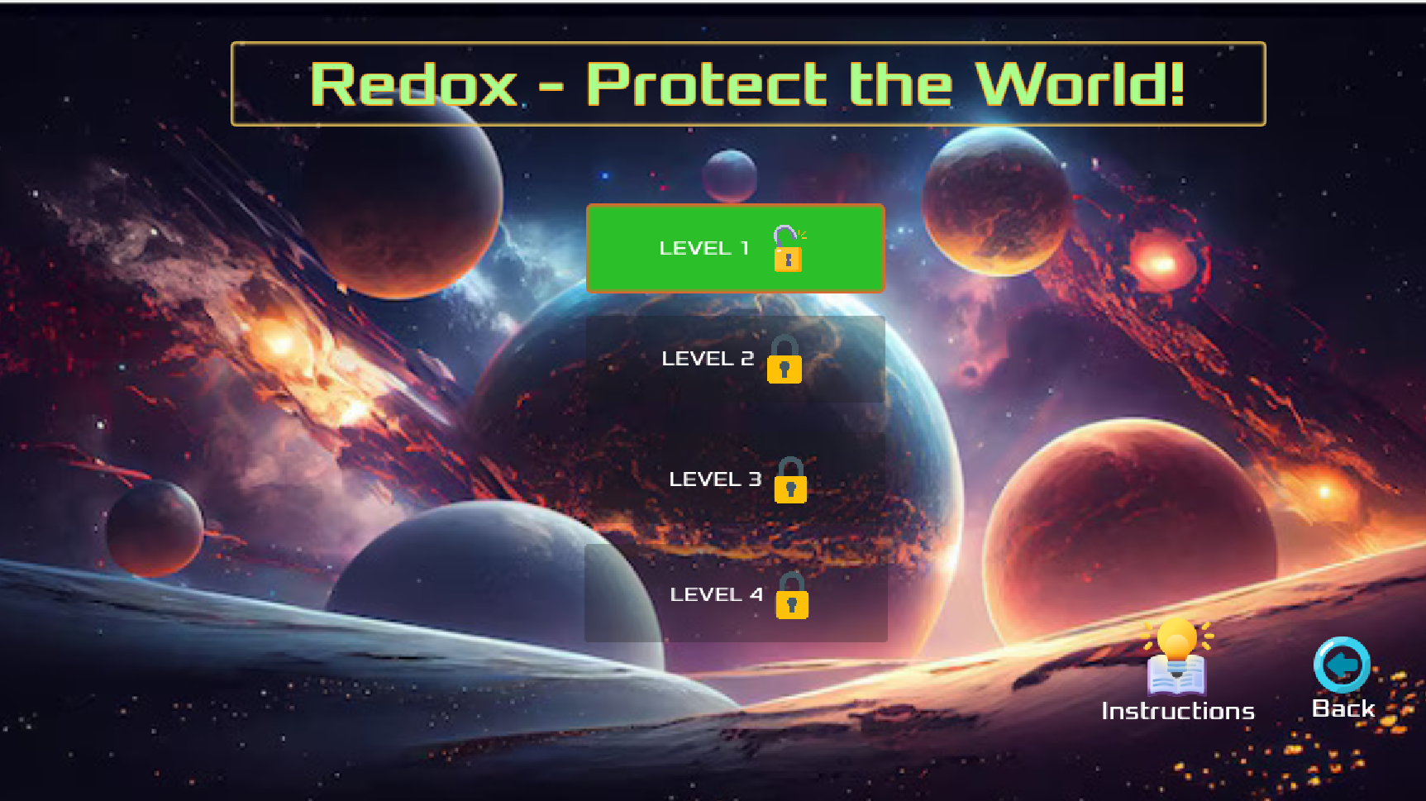

7.3.4 Level 1 Screen
- Initially it has “Start Level” button, and the game starts upon clicking it.
- Level 1 Screen has black colored galaxy as moving background along with the planet and satellite images.
- The “player” (Plane) will be at the bottom of the screen that will move left and right by pressing the left and right buttons on the keyboard.
- There will be a “Progress bar” also known as Knowledge meter that increases when player shoots correct answer.
- There will be 3 lives below the progress bar which will disappear one by one upon shooting wrong answer. The screen changes to “Game over” screen if player lose all the lives.
- The “Quit” button will be at the right side that navigates to level selection(back to main menu screen) if the player wants to quit.
- Options will fall with the speed of 25*0.8 pixels per second in this level.
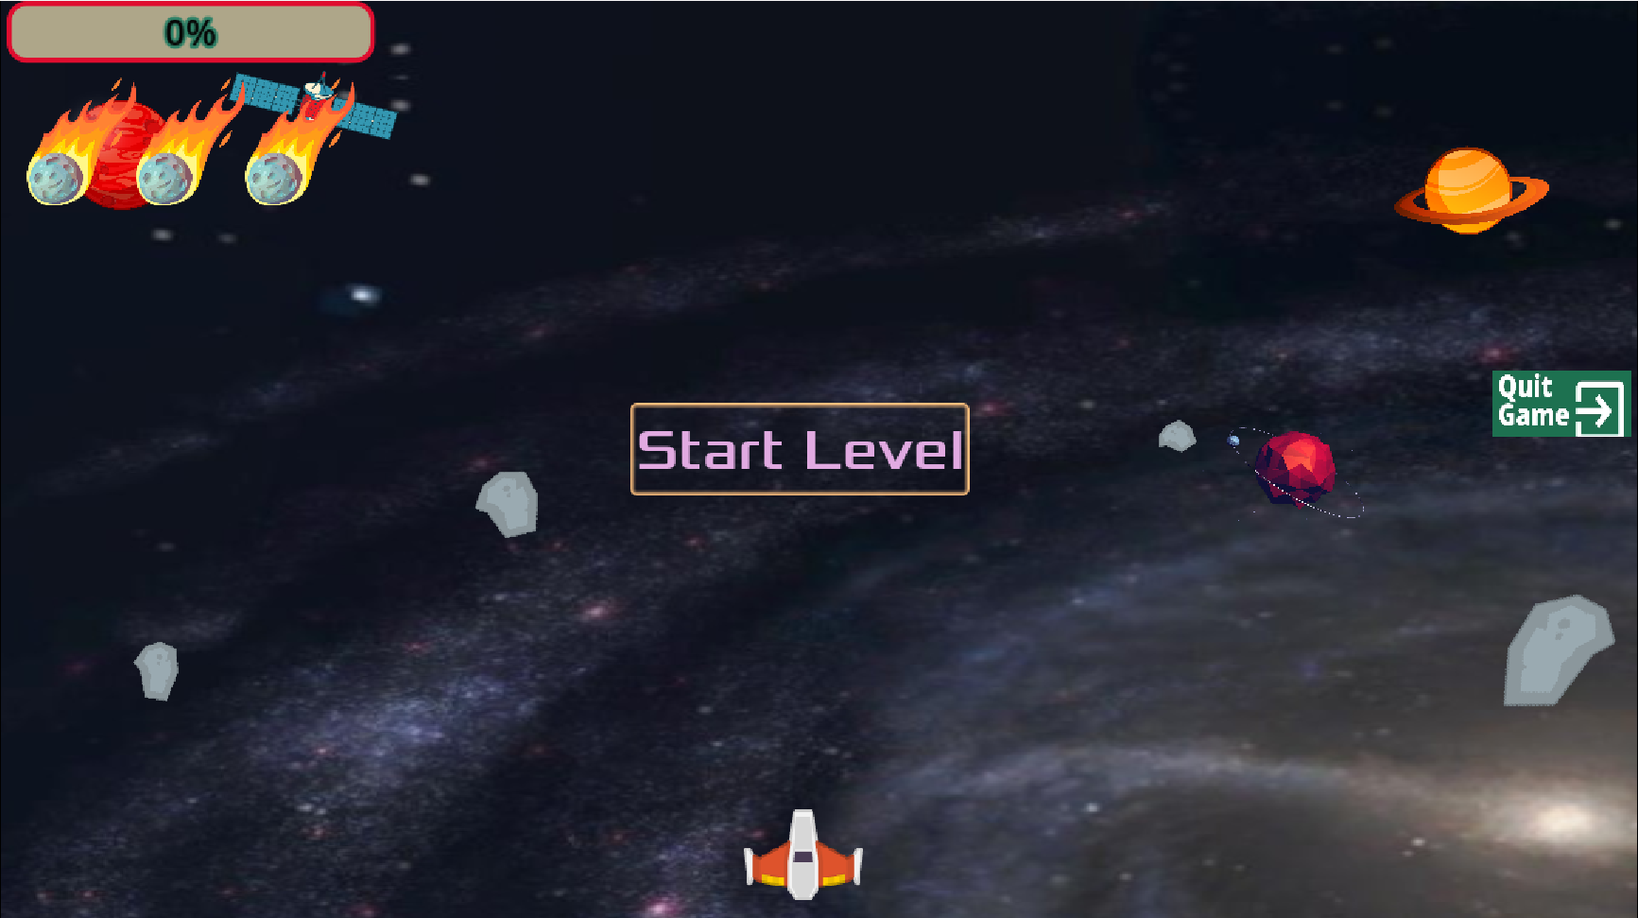

7.3.5 Level 1 Winning Screen
Winning screen will be appearing upon player shoots 7 out of 10 random questions in level 1 Which will be brown colored background with an astronaut image along with plane firing with cherishing audio.
- It has player score on it and says “Congratulations. You are well on your way to become redox master”.
- “Menu” button will be at the bottom of the screen that navigates “Main menu” upon clicking and it shows unlock image on level 2.
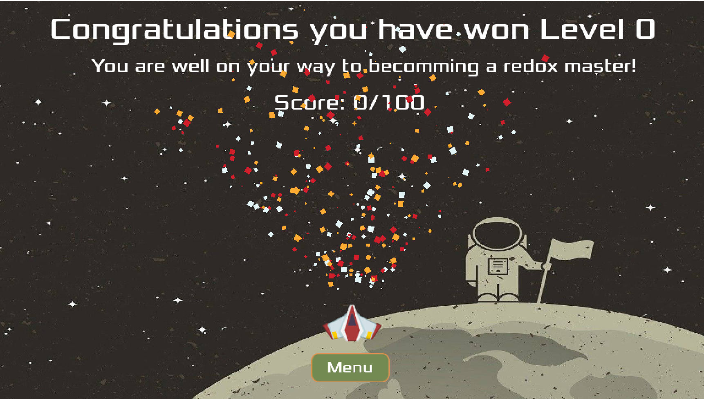

7.3.6 Level 1 Losing Screen
If the player failed to score the 70% out of 100 or loses all the 3 lives screen changes to “Game over” screen. It has navy blue colored background with player score on it along with the plane crashing image. “Menu” button will be at the bottom of the screen that navigates “Main menu” upon clicking and it still shows lock image on level 2.
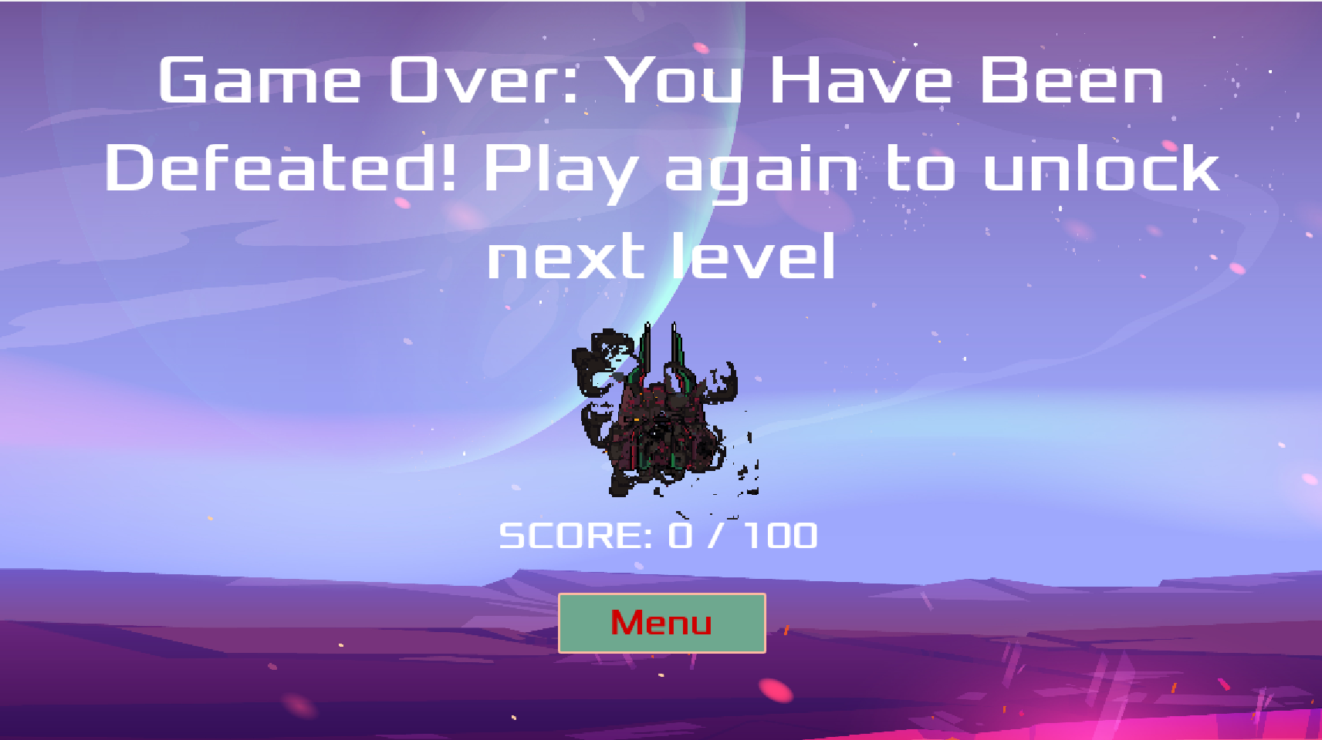

7.3.7 Level 2 Screen
- Initially it has “Start Level” button, and the game starts upon clicking it.
- Level 2 Screen has blue colored sky with stars as moving background along with the planet and satellite images.
- The “player” (Plane) will be at the bottom of the screen that will move left and right by pressing the left and right buttons on the keyboard.
- There will be a “Progress bar” also known as Knowledge meter that increases when player shoots correct answer.
- There will be 3 lives below the progress bar which will disappear one by one upon shooting wrong answer. The screen changes to “Game over 2” screen if player lose all the lives.
- The “Quit” button will be at the right side that navigates to level selection(back to main menu screen) if the player wants to quit.
- Options will fall with the speed of 25*1.2 pixels per second in this level.
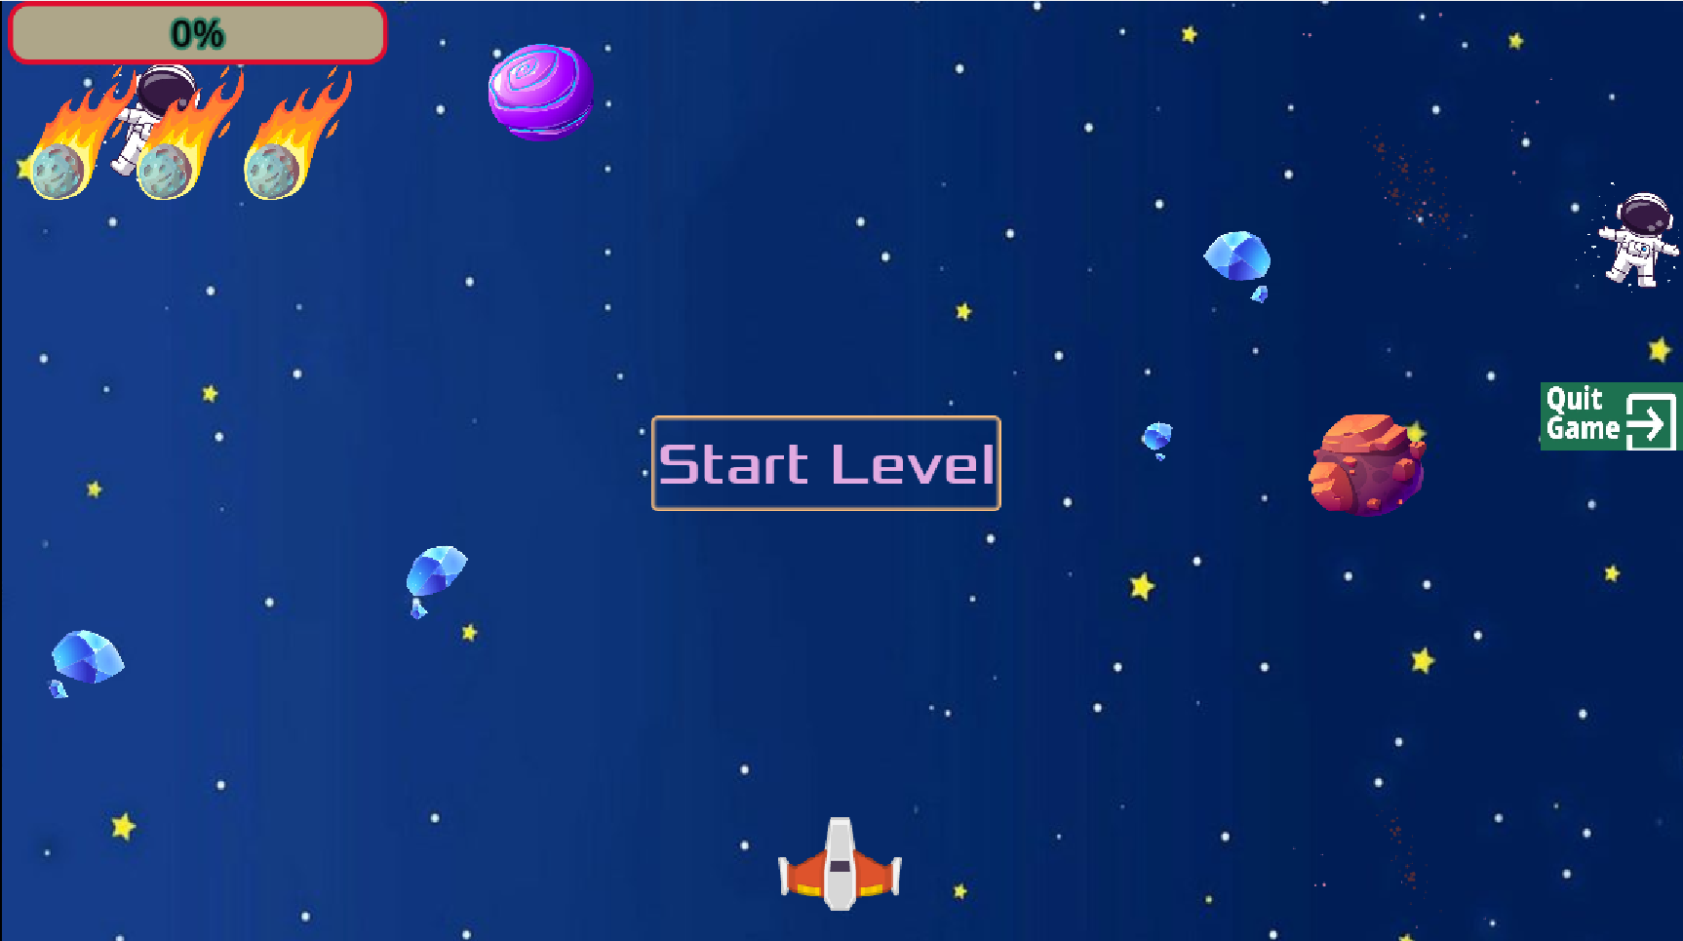

7.3.8 Level 2 Winning Screen
Winning screen will be appearing upon player shoots 7 out of 10 random questions in level 2 same as level 2 with increased speed of the options. It will be brown colored background with an astronaut image along with plane firing with cherishing audio.
- It has player score on it and says, “you are well on your way to become redox master”.
- “Menu” button will be at the bottom of the screen that navigates “Main menu” upon clicking and it shows unlock image on level 3.
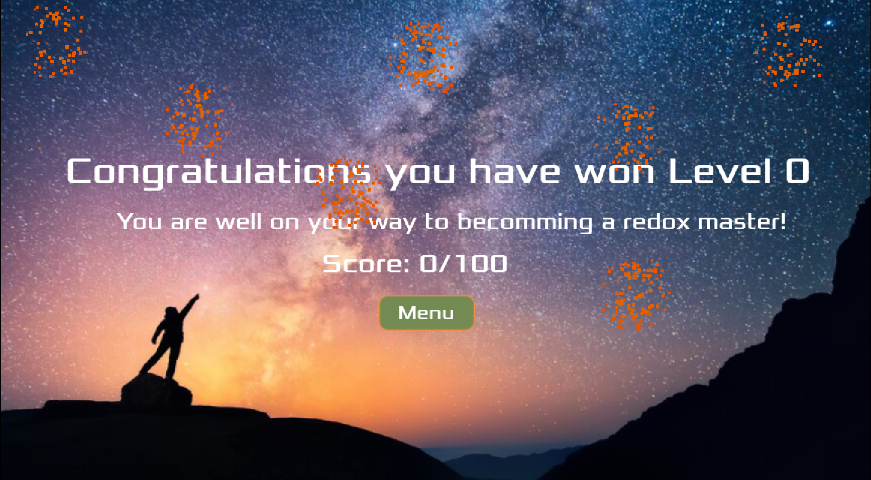

7.3.9 Level 2 Losing Screen
If the player failed to score the 70% out of 100 or loses all the 3 lives in level 2, screen changes to “Game over 2” screen. It has black colored background with player score on it along with the orange-colored leaves image. “Menu” button will be at the bottom of the screen that navigates “Main menu” upon clicking and it shows lock image on level 3.
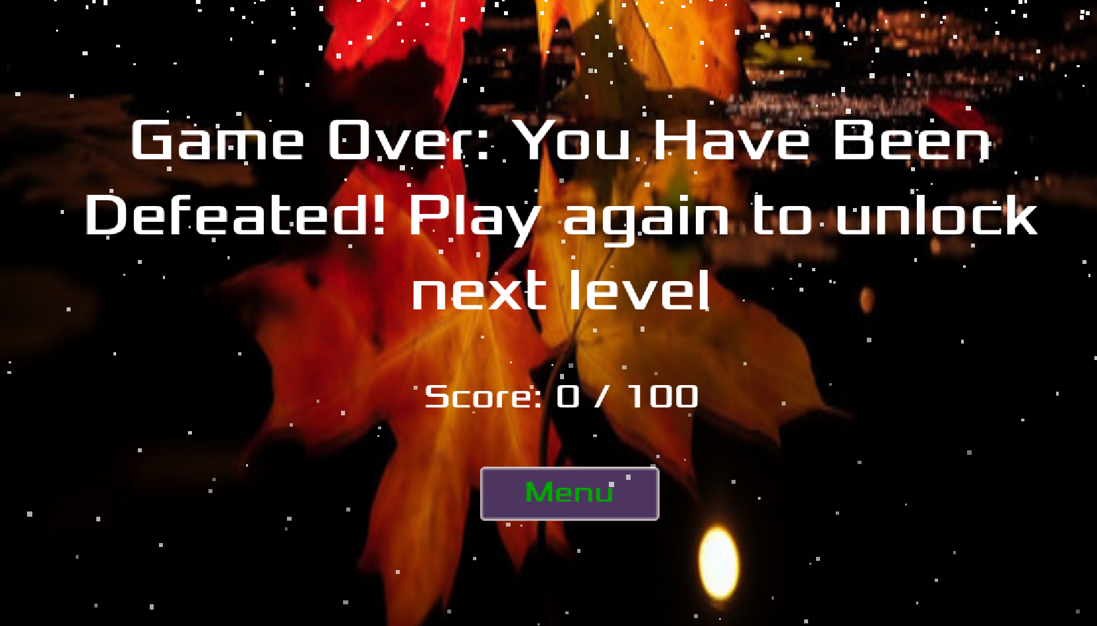

7.3.10 Level 3 Screen
- Initially it has “Start Level” button, and the game starts upon clicking it.
- Level 3 Screen has blue and pink colored sky with stars as moving background along with the planet and satellite images.
- The “player” (Plane) will be at the bottom of the screen that will move left and right by pressing the left and right buttons on the keyboard.
- There will be a “Progress bar” also known as Knowledge meter that increases when player shoots correct answer.
- There will be 3 lives below the progress bar which will disappear one by one upon shooting wrong answer. The screen changes to “Game over 3” screen if player lose all the lives.
- Level 3 has “Resume” button which will pause and resume upon clicking it.
- The “Quit” button will be at the right side that navigates to level selection (back to main menu screen) if the player wants to quit.
- Options will fall with the speed of 25*0.5 pixels per second in this level because of hard level.
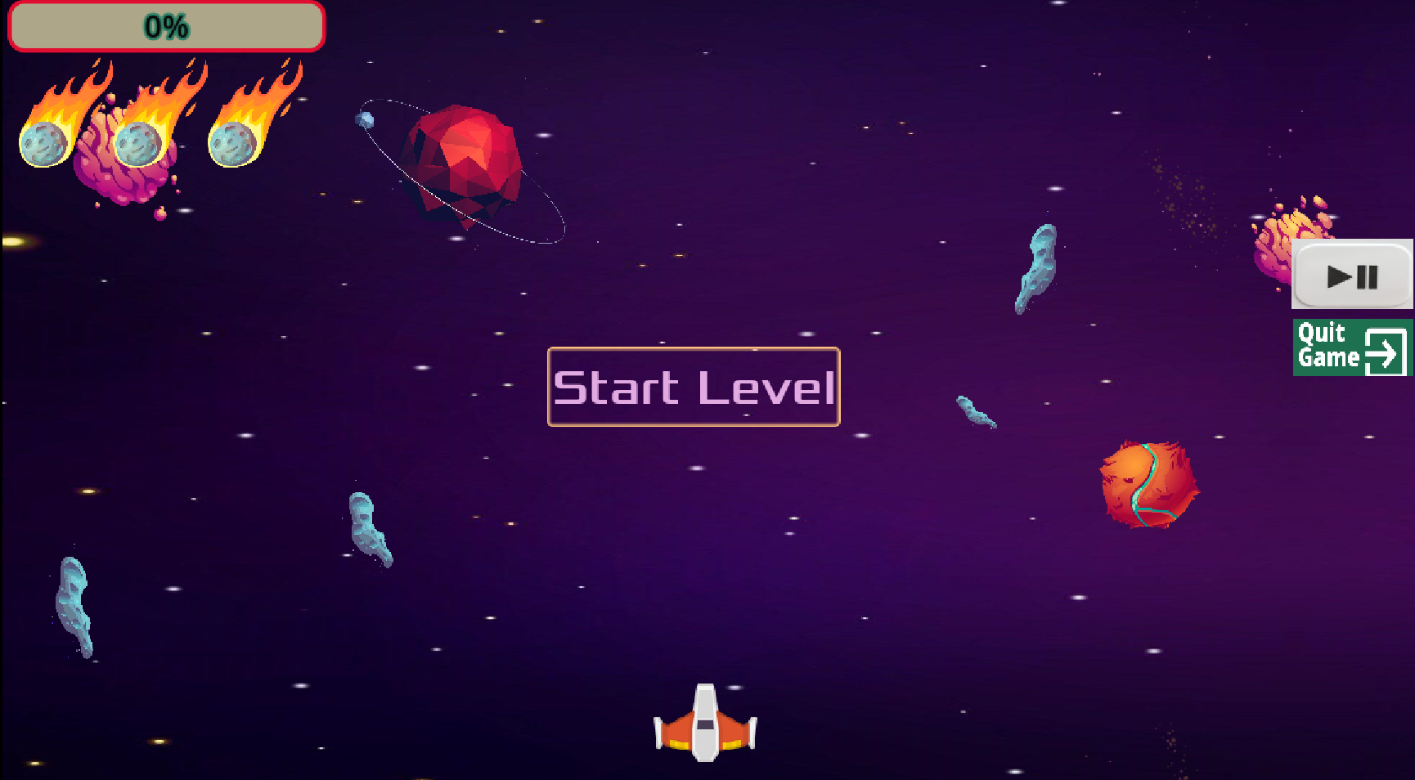

7.3.11 Level 3 Winning Screen
Winning screen will be appearing upon player shoots 7 out of 10 random questions less speed of the options. It will be black and fire colored background with an astronaut image along with plane firing with cherishing audio.
- It has player score on it and says, “you are well on your way to become redox master”.
- “Menu” button will be at the bottom of the screen that navigates “Main menu” upon clicking and it shows unlock image on level.
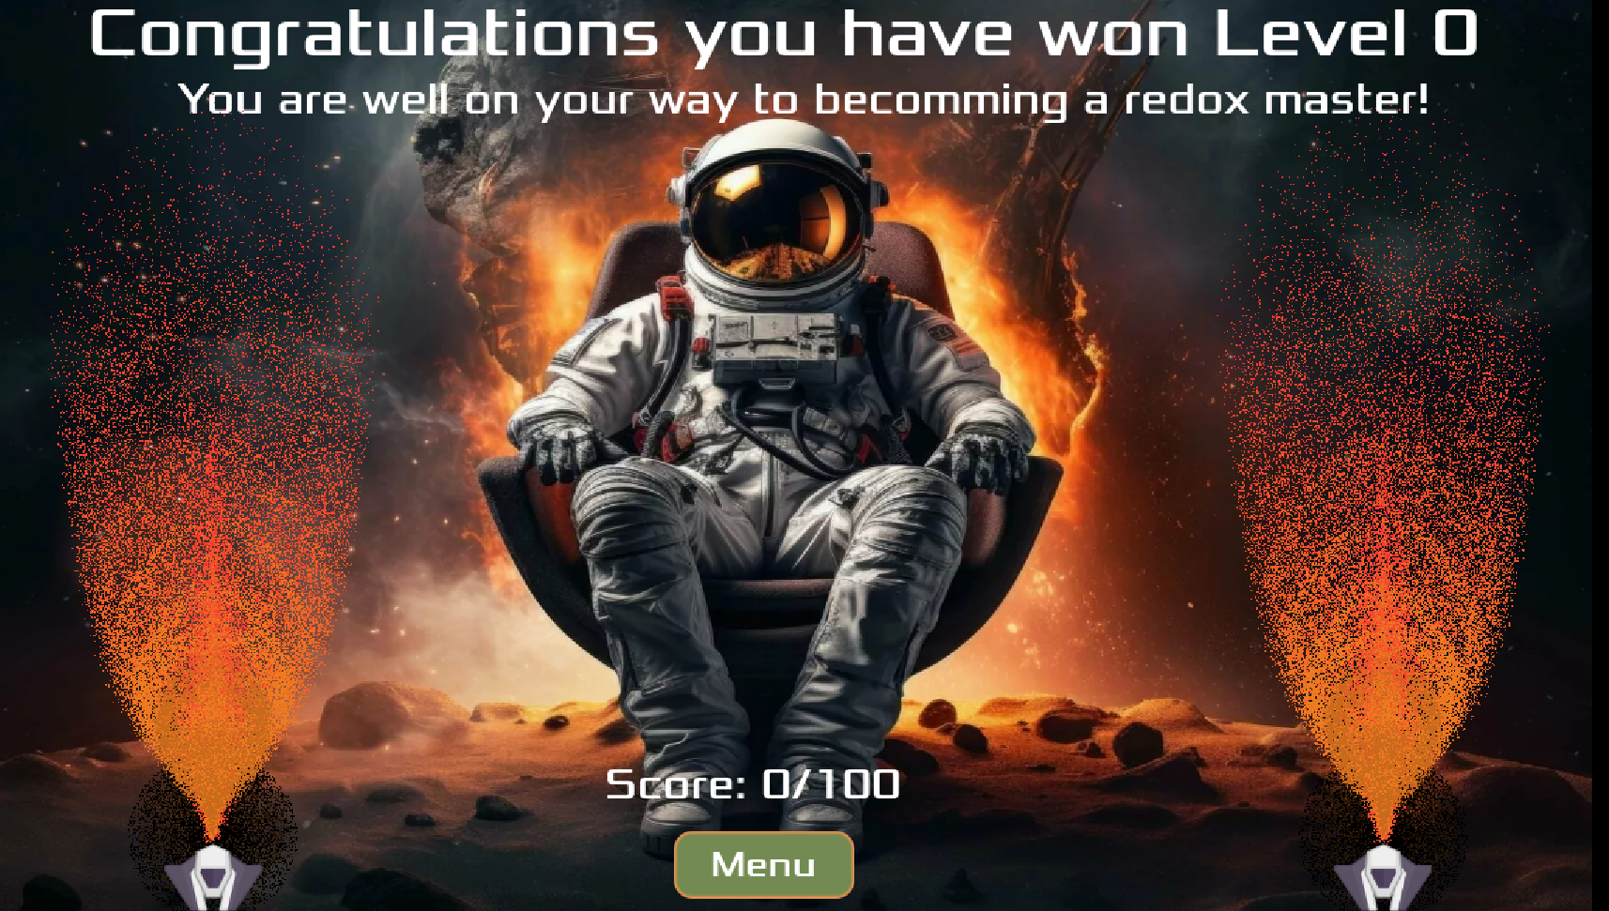

7.3.12 Level 3 Losing Screen
If the player failed to score the 70% out of 100 or loses all the 3 lives in level 3, screen changes to “Game over 3” screen. It has black and green colored forest background with player score on it along with the rainfall image. “Menu” button will be at the bottom of the screen that navigates “Main menu” upon clicking and it shows lock image on level 4.
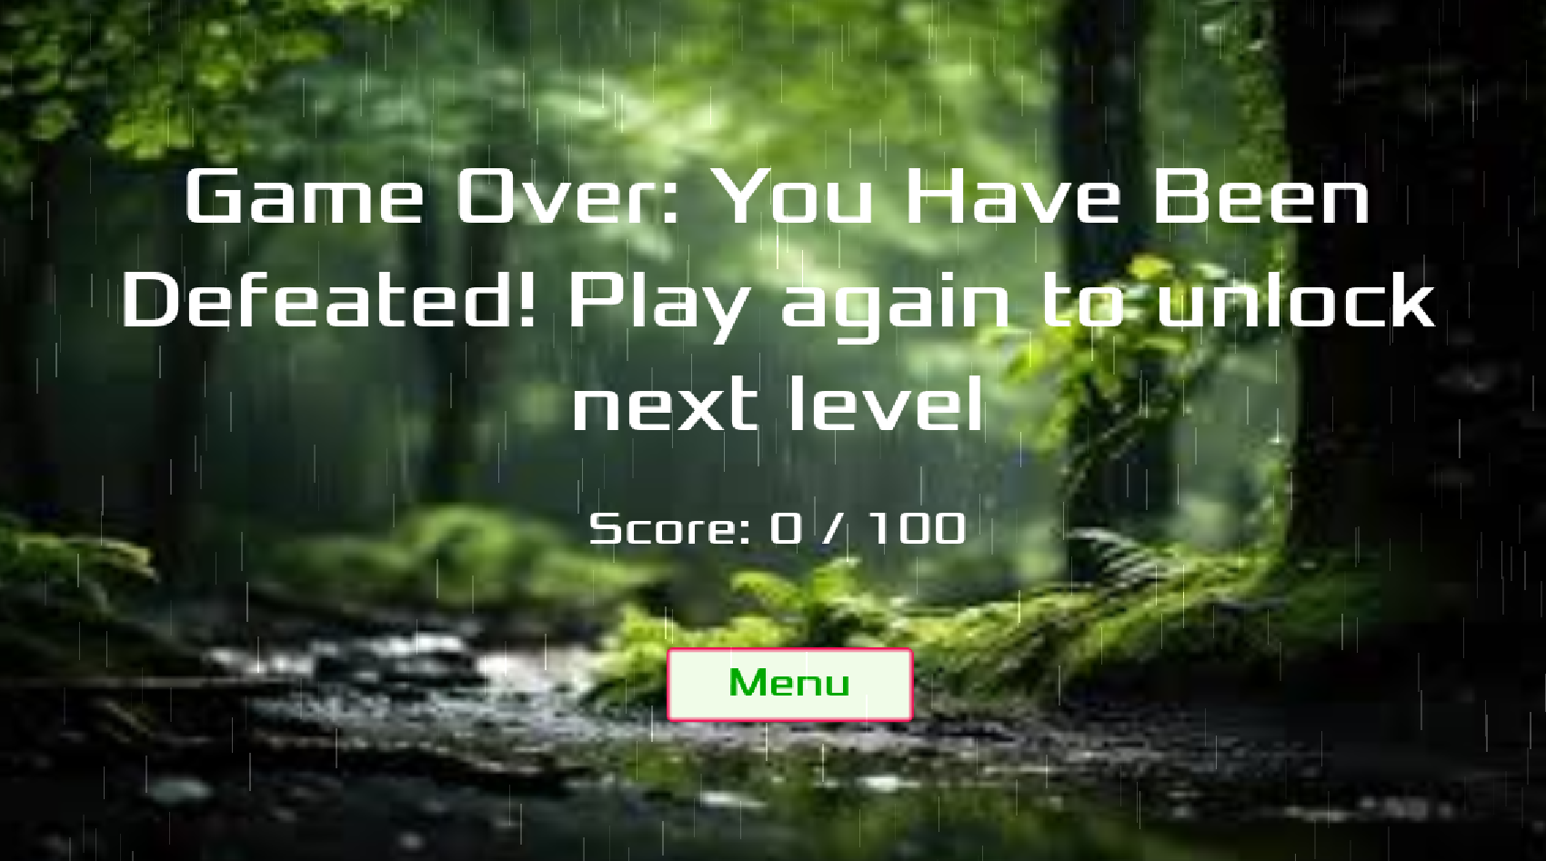

7.3.13 Level 4 Screen
- Initially it has “Start Level” button, and the game starts upon clicking it.
- Level 4 Screen has blue and pink colored sky with stars as moving background along with the planet and satellite images.
- The “player” (Plane) will be at the bottom of the screen that will move left and right by pressing the left and right buttons on the keyboard.
- There will be a “Progress bar” also known as Knowledge meter that increases when player shoots correct answer.
- There will be 3 lives below the progress bar which will disappear one by one upon shooting wrong answer. The screen changes to “Game over 4” screen if player lose all the lives.
- Level 4 has “Resume” button which will pause and resume upon clicking it which is same as level 3.
- The “Quit” button will be at the right side that navigates to level selection (back to main menu screen) if the player wants to quit.
Options will fall with the speed of 20 pixels per second and will float on screen once it reaches to certain distance.

7.3.14 Level 4 Winning Screen
Winning screen will be appearing upon player shoots 7 out of 10 random questions less speed of the options. It will be black and fire colored background with an astronaut image along with plane firing with cherishing audio.
- It has player score on it and says, “you are well on your way to become redox master”.
- “Menu” button will be at the bottom of the screen that navigates “Main menu” upon clicking and it shows unlock image on level.

7.3.12 Level 4 Losing Screen
If the player failed to score the 70% out of 100 or loses all the 3 lives in level 3, screen changes to “Game over 3” screen. It has black and green colored forest background with player score on it along with the rainfall image. “Menu” button will be at the bottom of the screen that navigates “Main menu” upon clicking and it shows lock image on level 4.

7.3.13 Professor’s Login
Professor will be having website which is used for managing the questions of each level.
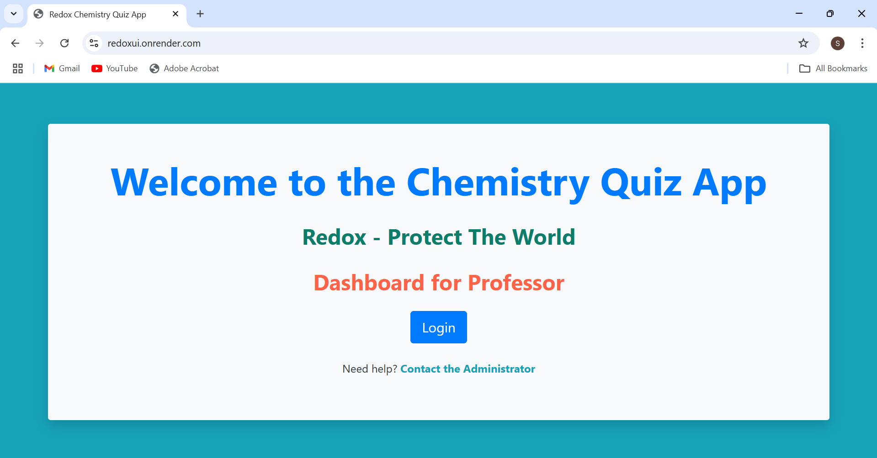
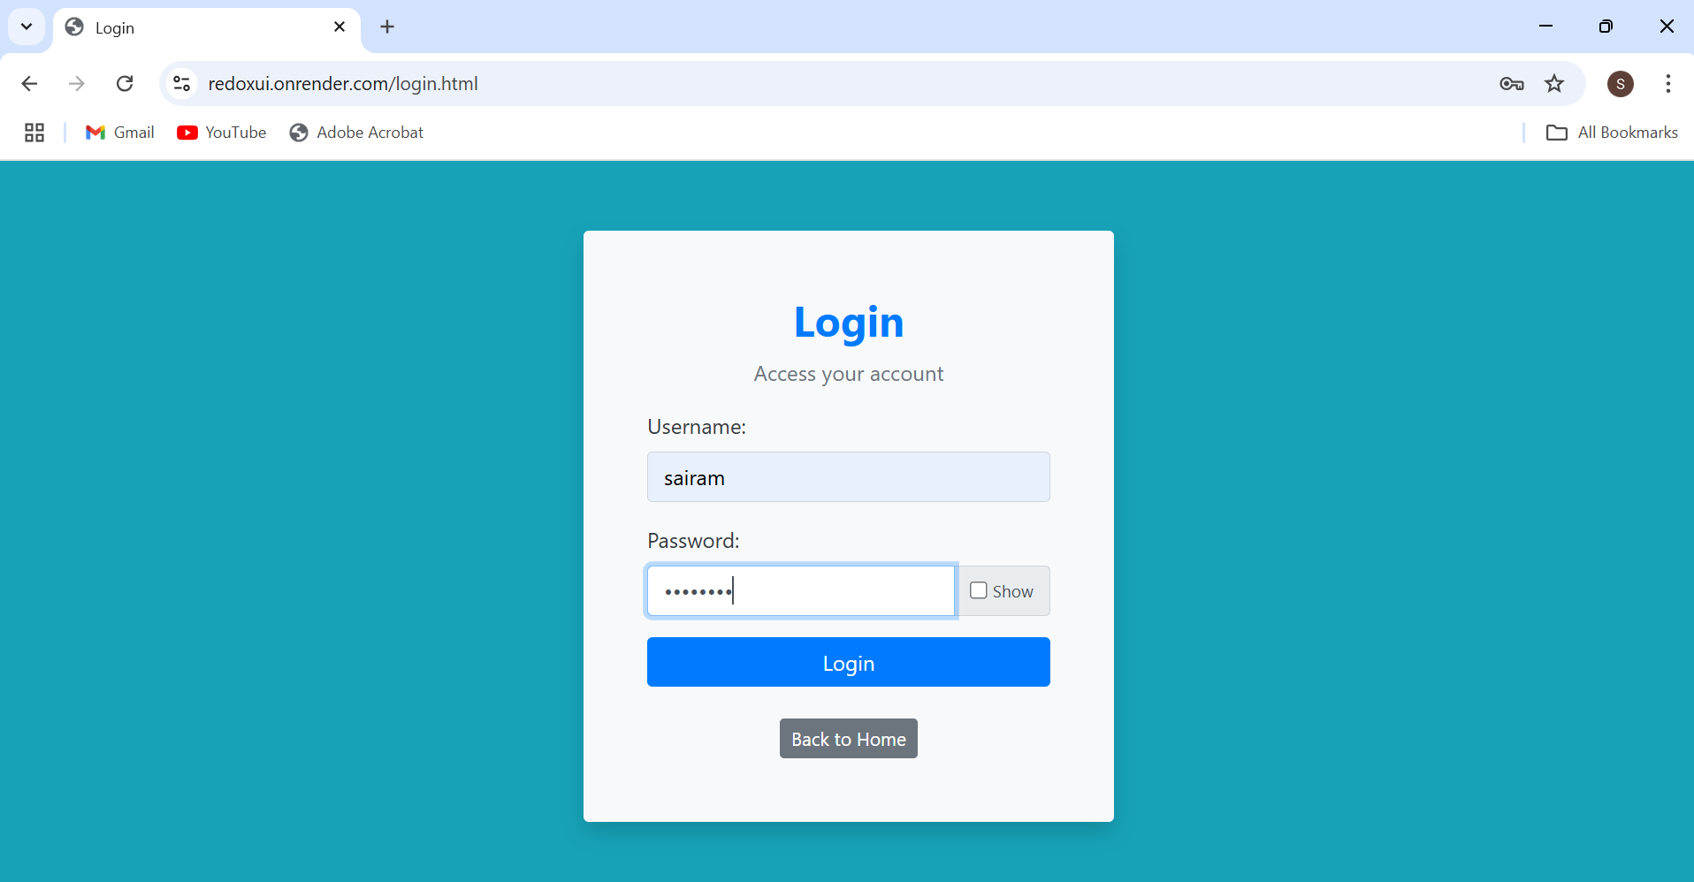After logged in to professor’s site it has various features
- The initial page shows “Game Statistics” which represents Number of students registered and Number of students completed the levels.

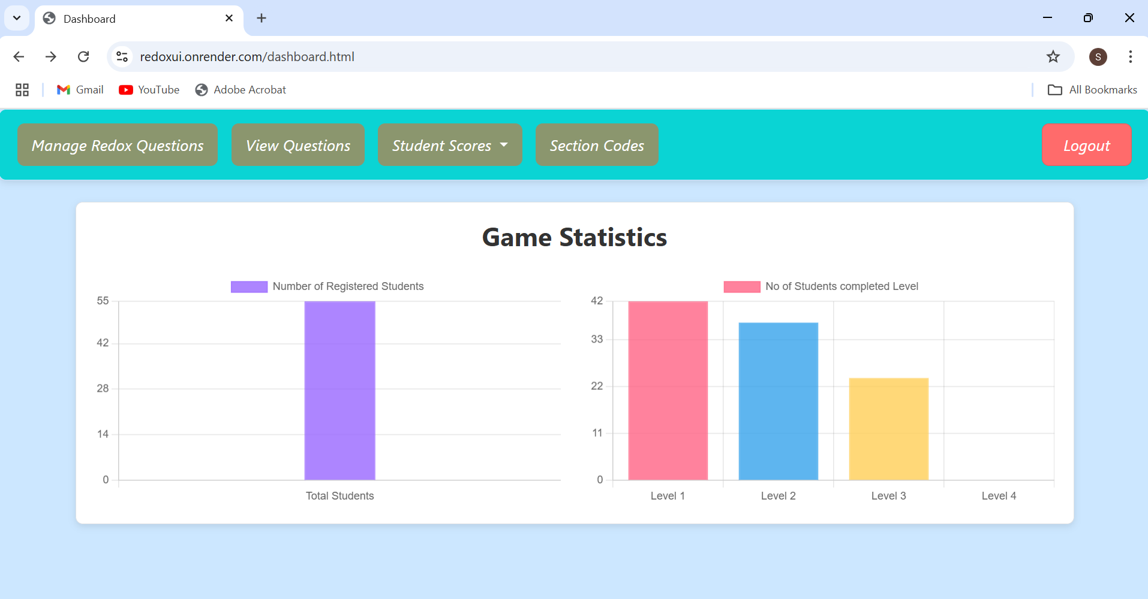

Add Redox Questions

This page will be used for adding the questions to the database by the professor by selecting the appropriate levels.
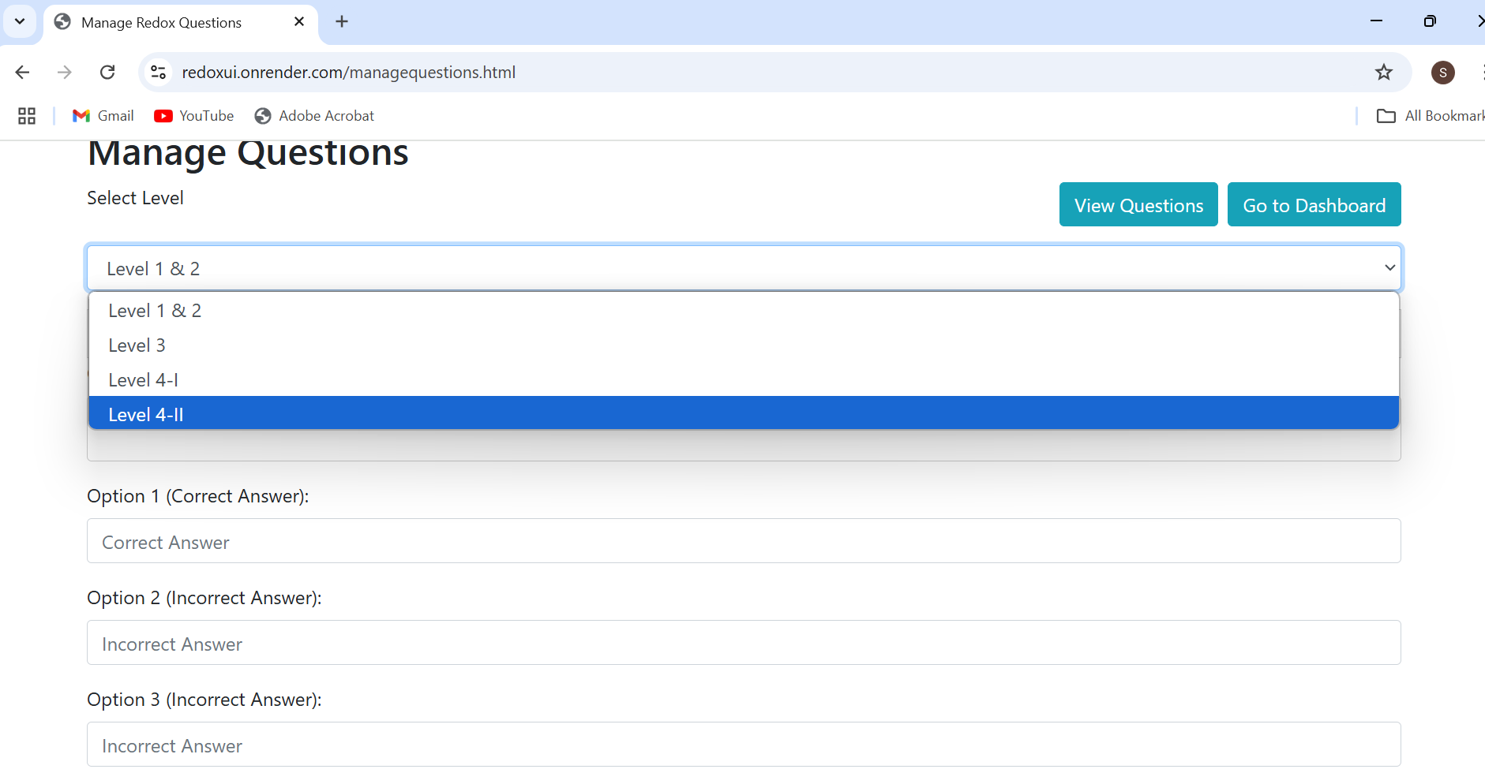

Viewing existing Questions

This page consists of all the questions based on level with “Edit” and “Delete” buttons that can perform CRUD operations.
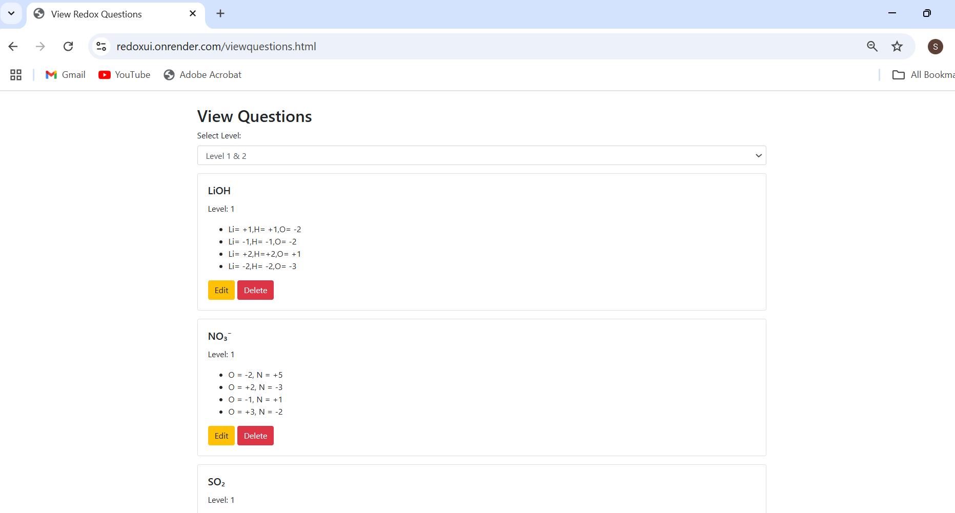

This pop-up option also supports subscript and superscript selection.
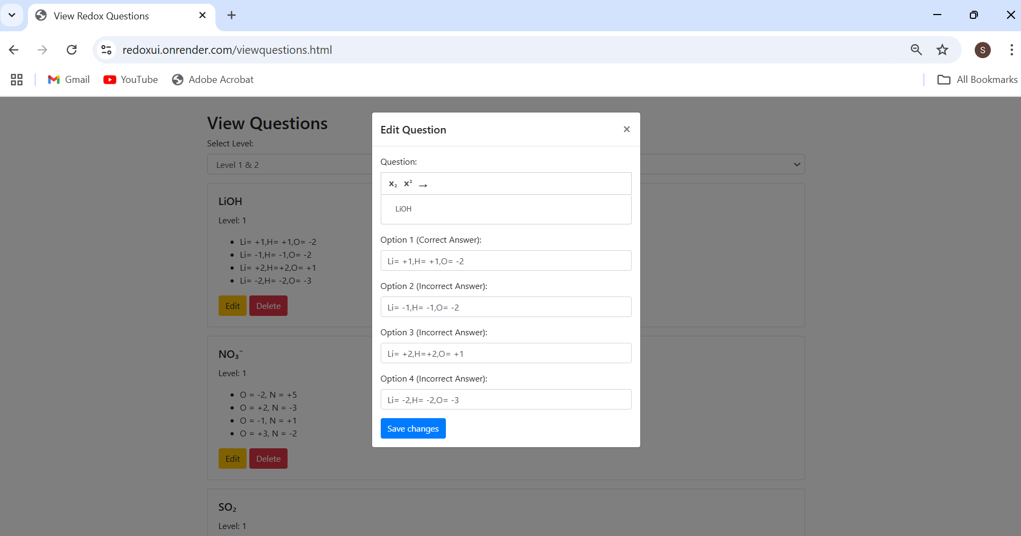

Students Score

Here Admin (Professor) will be able to see students score based on sections and download them as Excel.

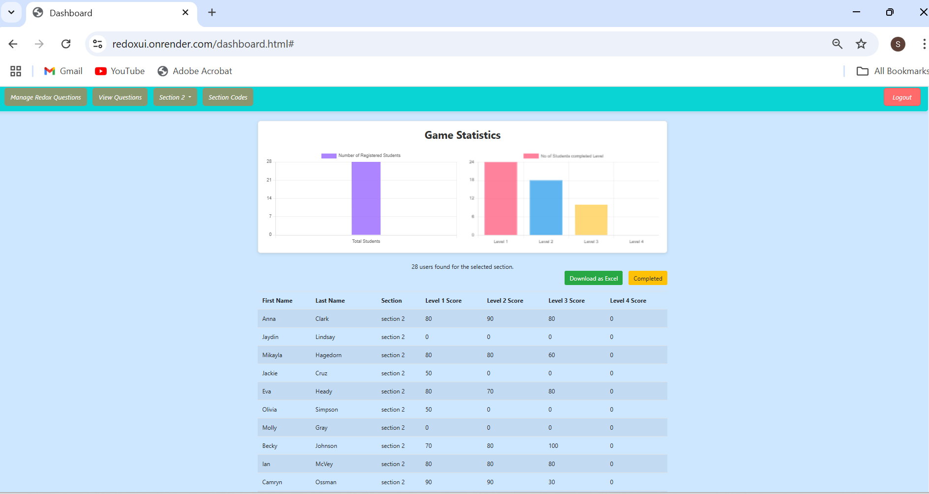
If downloaded it will be directly saved as an Excel format into their device.
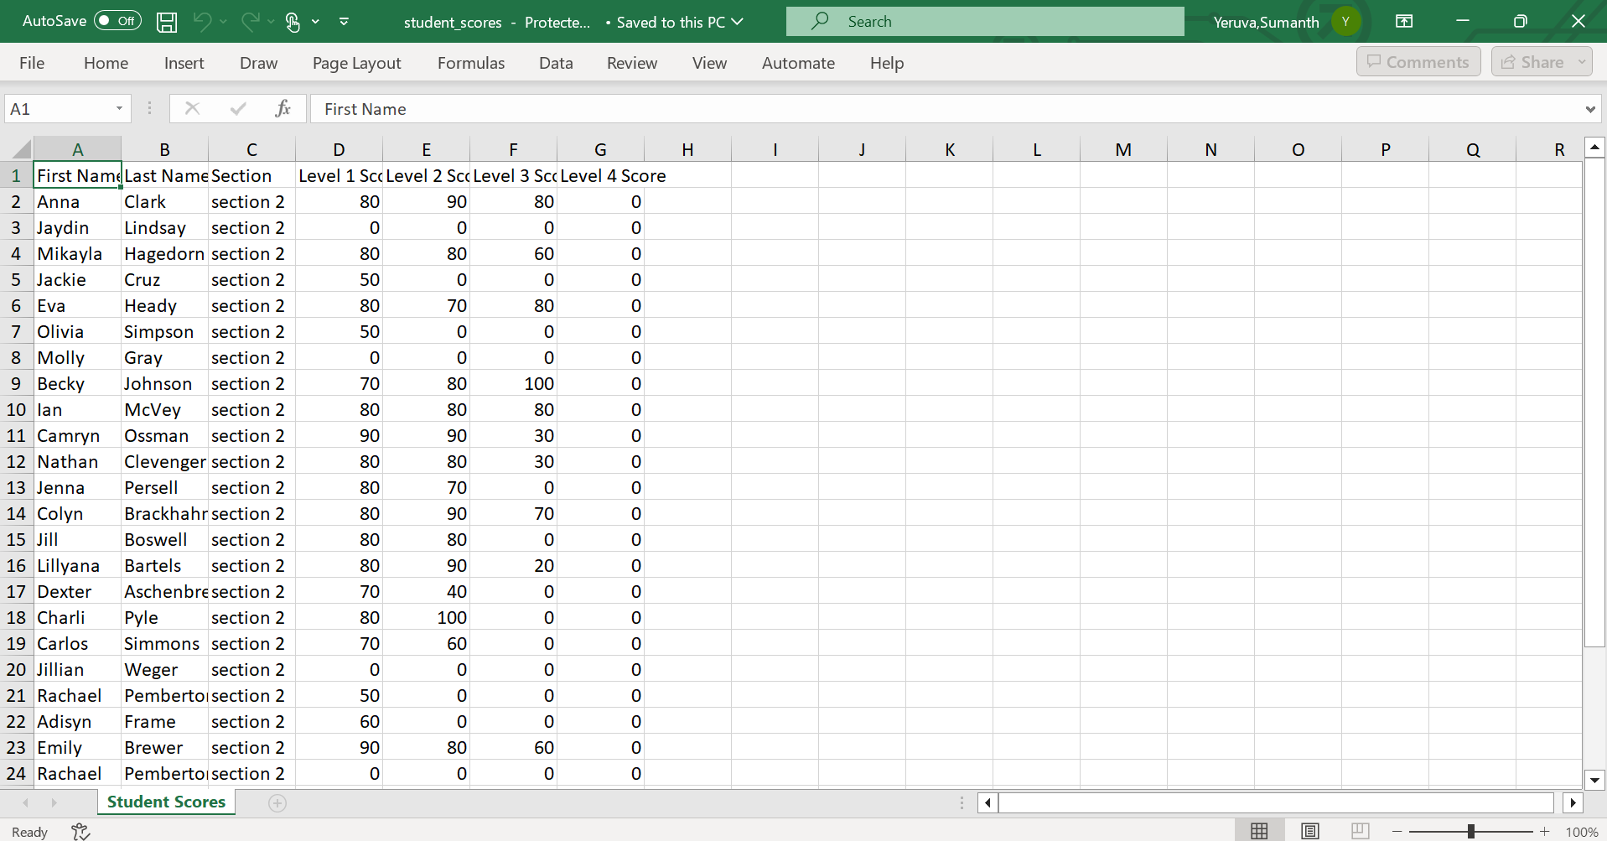

Section codes

This page facilitates the professor to allocate the codes for each section that helps students to register in their own section (mentioned in 7.3.2).

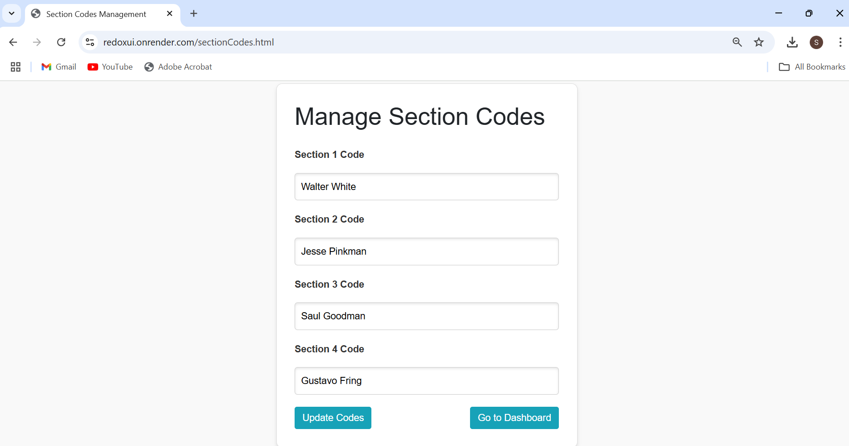

7.4 Project Website Links

Project has been uploaded on the itch.io which has various 2D and 3D games on it.
UI Link (Professor Dashboard): https://redoxui.onrender.com/
Itch.io Link: https://redox-protect-the-world.itch.io/redox

7.5 GitHub Link

GitHub Link: https://github.com/JPranathiReddy/GDP_REDOX_TEAM1

